P1

**Contingency Table**

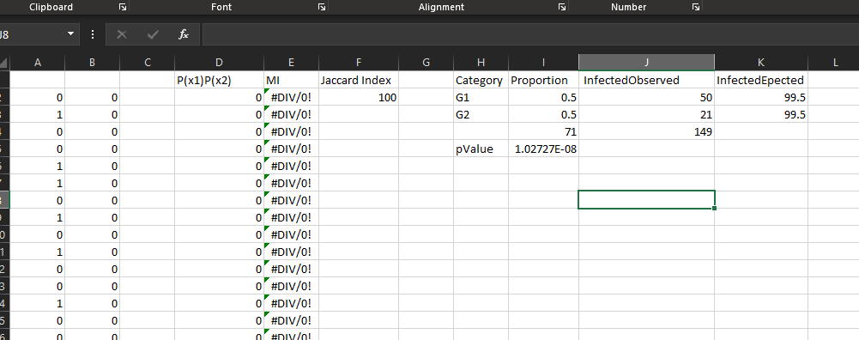

**Mutual Information**

Formula = I(x1,x2) = P(x1,x2) log (P(x1,x2)/P(x1)P(x2)

The information when multiplyed with each other came out to 0 which did not allow use to get the value. The problem when written gives us the ablilty to convert the equation giving us the value 1 which in log comes out to zero which in turn give use I = 0. Meaning that the data does not tell us anything about the data being conneted to each other. Just cause one happen does not mean the other to result.

**Jaccard Index**

Formula = (the number in both sets) / (the number in either set) * 100

Number in both sets = 2

Number in either set = 2

(2/2) * 100 = 100

Jaccard Index = 100

**Chi-Squared X2**

$X^{2}=\sum_{i=i}^{k}{{(\left(O_{i}-e_{i}\right)}^{2})/e_{i}}$

The code in excel is CHISQ.TEST(I4:J4,K2:K3) or (71:149,99.5,99.5)

pValue/Chi-S = 1.02727E-08

P2

2.1A:

α Level = 0.5

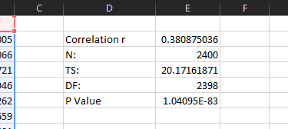

The correlation that we were able to gather shows the value has very little to do with each other due to the negative association value. The P-value also seems to be lower than the alpha which would result in the rejection of the null hypothesis. The association between the data clealry tells me the genes have no significant to each other. From the data gathered.

2.2B:

α Level = 0.5

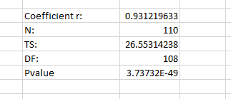

The data that was given was able to give us a correlation that is positive in the terms of association. The P-value was also lower than the alpha level and that would result in the rejection of the null hypothesis. The association between the data clearly show the genes have a very high association with each other and the graph also shows it seeing how they move upward in slope.

2.3C:

α Level = 0.5

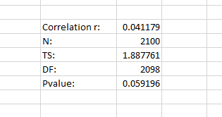

The data that was given was able to give us a correlation that is negative, but very little it’s near the center in terms of association. The P-Value was also higher that the the Alpha level which means we can’t reject the null hypothesis. The association between the data cleaely shows the genes have some association to each other the graph shows that.

2.4D:

A

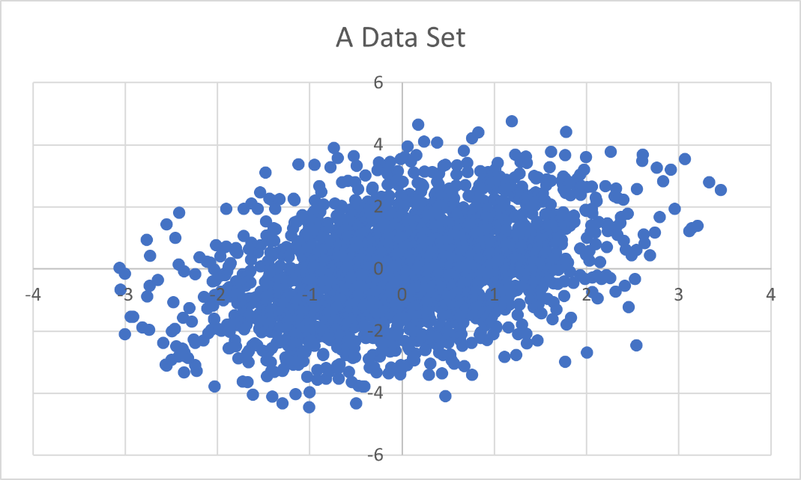

B

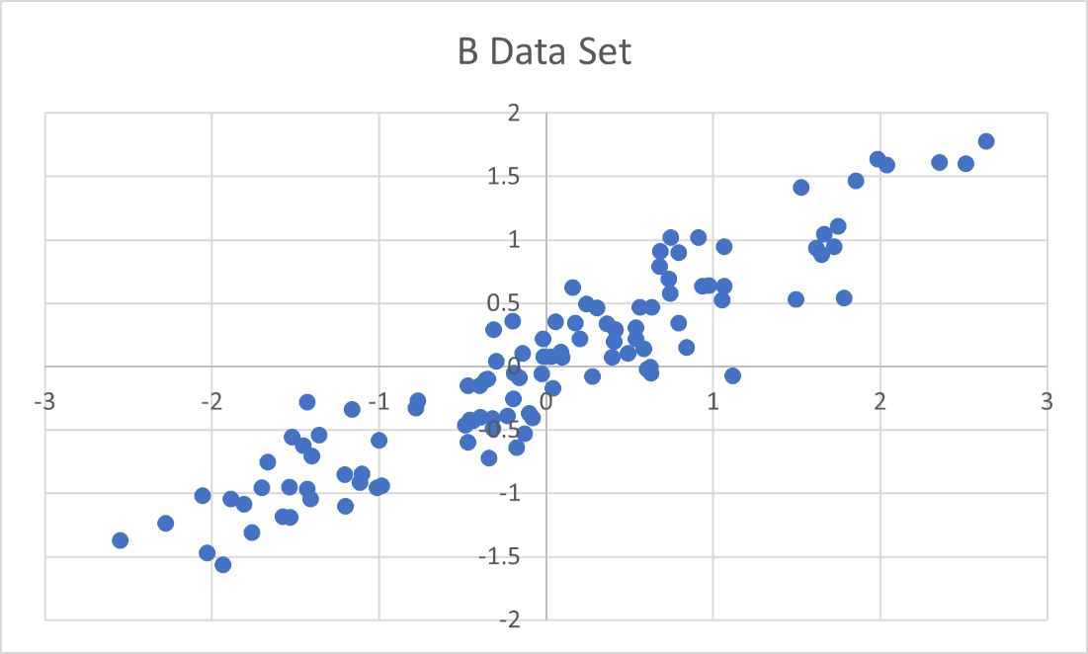

C

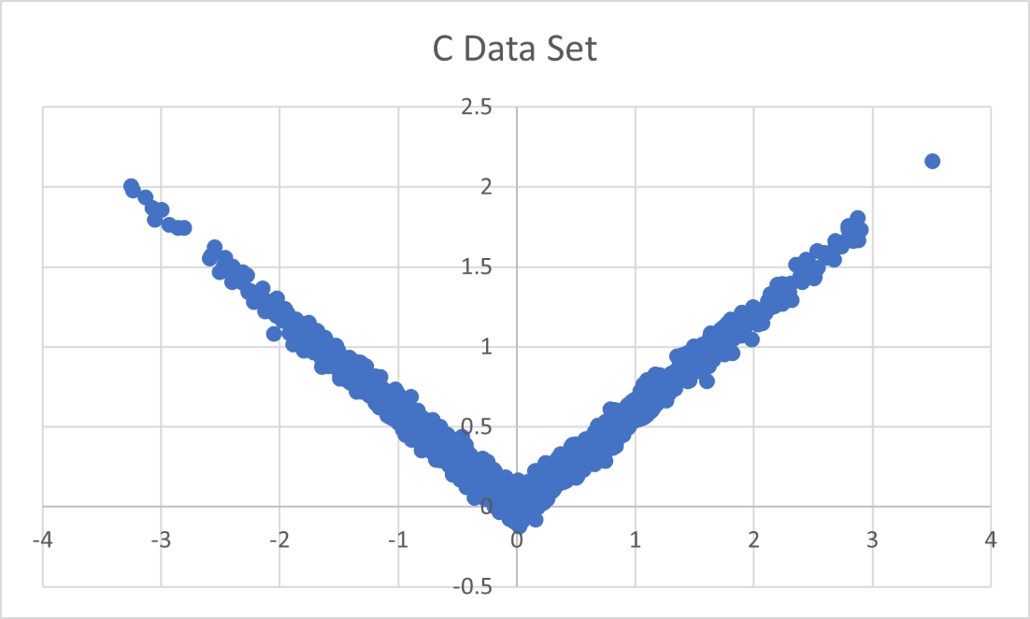

2.5E:

B data set gives the higher correlation with the number of .93 which shows that data has a very high correlation with one another. The C data set has a higher P-Value which tells us that we can’t reject the null hypothesis and giving us the higher association shown by the graph. The data set do show a good association with the correlation and P-Value. C to me seems the data set to have a higher association due to the weird V the graph is displaying.